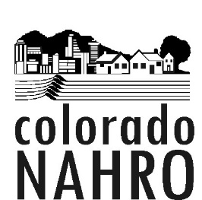

Colorado NAHRO Board of Directors
AGENDA
March 19, 2019, 9:30 am – 11:00 am
Metro West Housing Solutions
575 Union Ave., Lakewood, 80228
Call in #- 605-475-6006, Passcode 4786948#

I. Welcome and Call to Order
II. Approval of Minutes from February 19, 2019
III. President's Report- Troy Gladwell
- Polis/ Zenzinger Outreach
- Rick Garcia Invite to Conference
IV. Financial Report- Carol McGrath
- YTD Financials
V. Old Business/ Updates
A. Commissioner’s Summit Recap
B. 2019 Election Committee
C. 2019 Conference Update
D. Colorado Legislative Update- Elena Wilkin, Housing Colorado and Craig Maraschky
E. Outreach Coordinator- Troy
F. Bylaws Amendment Committee
G. Legislator of the Year Award Resolution
VI. New Business
- Legislative Agenda
- Congressional Visits Schedule
- MPNAHRO Strategic Planning Meeting Summary and Issues
- National NAHRO Committee Reports/ Business
VII. Meeting Schedule- Outlook invitations sent
VIII. Adjournment

