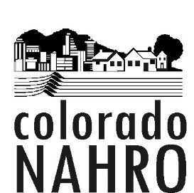
2019 Member Dues Form

Agency or Name___________________________________________________

Address__________________________________________________________

City, State, Zip_____________________________________________________

Contact Person_____________________________________________________

Email____________________________ Telephone________________________

I. PUBLIC HOUSING AGENCY
Number of PH Units________________________
Number of HCV Units_______________________
Number of Project Based Section 8 Units___________
Number of Other HUD Units__________________
Number of LIHTC Units______________________
Total units:________x .44___________________
TOTAL AGENCY DUES:* $_________________

*Less than 75 units pay $35.00.

II. COMMUNITY DEVELOPMENT AGENCY or LOCAL, STATE OR GOVERNMENT AGENCIES
Includes Redevelopment Authority, Downtown Development Authority as well as city or county departments and quasi-governmental agencies. Dues are determined by the size of the community in which you operate or the legal jurisdiction size in the case of special district authorities.

*Less than 50,000 population - $110.00
*Greater than 50,000 population - $165.00
*Local, state or other government agency - $275.00

III. NONPROFITS & AFFILIATES

*This category applies to consultants, property management firms, etc.
All members in this category - $95.00

IV. CORPORATE PARTNERS

All for-profit companies, banks, corporations and vendors- $220.00

V. INDIVIDUAL

*All individuals - $60.00
Please note that member dues are to be paid separately from Conference registration fees.
Make checks payable to: Colorado NAHRO
Mail Checks to: Attention Carol McGrath, Treasurer
Housing Catalyst

1715 West Mountain Ave., Fort Collins, Colorado 80521
Questions? Contact Dave Martens at 303-447-0690 davem@mpnahro.org
(please contact us with any corrections to you contact information)

