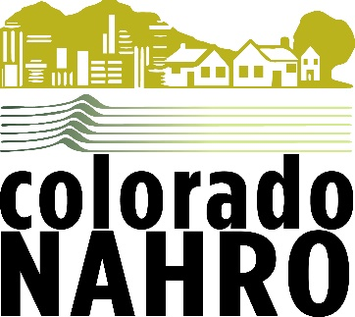
March 14, 2019
Dear Senator Bennet,
Colorado NAHRO (National Association of Housing and Redevelopment Officials) is happy to name Senator Michael Bennet as its 2018 Legislator of the Year. The award is given when a deserving Legislator exhibits accomplishments in legislative leadership for people and communities needing housing assistance. It recognizes individuals who champion the advancement of Colorado NAHRO’s policy agenda and legislative priorities.
We’d like to especially recognize and thank Senator Bennet for the following:
- Co-Sponsor of S 548 Affordable Housing Credit Improvement Act of 2017
- Continued Champion of the Low-Income Housing Tax Credit and Private Activity Bond Programs
- Supporter of increased funding for affordable housing and community development through both the HOME, Community Development Block Grants, Choice Neighborhood Initiative and Public Housing and Housing Choice Voucher Programs
- Support for homeless Veterans through the HUD-VASH Voucher Program
Senator Bennet will be officially recognized to our membership during the Colorado NAHRO annual conference Awards Luncheon on Thursday, May 16, 2019 at the Vail Marriott Mountain Resort in Vail, Colorado.
We understand that the Senator’s schedule will not allow him to attend the awards luncheon in Vail so we would like to present him with the award during our upcoming congressional visits to Washington DC on April 9th. The Senator is invited to provide a written or video response for the award for presentation to our membership at the May 16th luncheon.
Congratulations and thanks for your leadership and support.

Troy Gladwell
President, Colorado NAHRO

