COLORADO & MOUNTAIN PLAINS NAHRO
National Association of Housing and Redevelopment Officials
705 Iris Ave. Boulder, CO 80304 303-447-0690 (phone) 303-402--1959 (fax)
davem@mpnahro.org; www.conahro.org; www.mpnahro.org

Dear Prospective Sponsor, Exhibitor or Advertiser,

The 2018 Management and Maintenance conferences will be held May 14-18 at the Vail Marriott Resort Hotel and Conference Center, Vail, Colorado.

Colorado and Mountain Plains NAHRO (National Association of Housing and Redevelopment Officials) invite you to consider supporting our Association in one of the following ways:
- Be a sponsor of our annual conference May 14-18 in Vail, (page 3)
- Be an exhibitor or advertiser for our annual conference May 14-18 in Vail, Colorado (page 3)
- Become a corporate sponsor which combines some year-long benefits with conference sponsorship (page 2)

CORPORATE SPONSORSHIP- We are offering several year-long corporate sponsorships that provide added exposure for just slightly more investment (see page 2).

This year’s event is the premiere event in a six-state region (including Colorado, Utah, Montana, South Dakota, North Dakota, and Wyoming) for housing authorities, community development agencies and other affordable housing organizations. We expect 400+ delegates to attend the event. The conference is a great opportunity to put your products or services on display and meet the key decision-makers that use them.

The Maintenance Conference takes place on Monday and Tuesday, May 14-15 and caters to maintenance directors and maintenance staff. Workshops will be offered in electrical, plumbing, boilers, refrigeration, heating, AC, site saftety, inspections, sustainability and more. We expect 125+ attendees.

The Management Conference takes place Wednesday through Friday, May 16-18, and caters to executive directors, management staff, line staff and commissioners. A wide variety of workshops will be offered related to public housing, Section 8, community development, homelessness, rehab, resident services, housing development, finance, technology, national and state legislative priorities, and professional development. We expect 300+ attendees.

You have a choice of exhibiting at either the Maintenance Conference (May 14-15) OR at the Management Conference (May 16-18) OR you are welcome to exhibit at BOTH. Both conferences feature a Sponsor/ Exhibitor Reception on Monday, May 14 (Maintenance) and on Wednesday May 16 (Management).

WE WILL ALSO BE SCHEDULING A 45-MINUTE BREAK DURING ONE DAY OF BOTH CONFERENCES DEVOTED EXCLUSIVELY TO VENDOR VISTS (day and time TBA).

The Registration Form is on Page 4 of this packet.

Thank you for considering our event and don't hesitate to call if we can answer any questions. The deadline for registration is April 2, 2018. A complete package with all the logistical, lodging and program information will be sent out after receiving your registration. You may also access conference and lodging information at www.conahro.org.

Sincerely,

David Martens
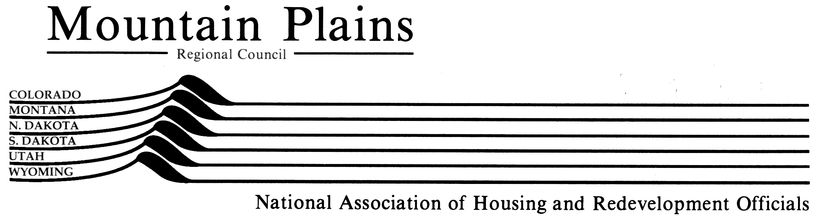
Regional Director
Mountain Plains NAHRO
303-447-0690
davem@mpnahro.org

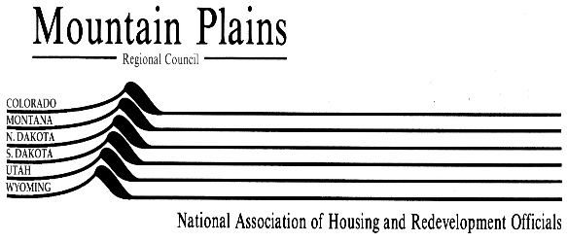

2018 COLORADO & MOUNTAIN PLAINS NAHRO

CORPORATE SPONSOR PROGRAM

Colorado and Mountain Plains NAHRO are offering prospective sponsors with an opportunity to leverage the many benefits of your regular conference sponsorship investment by making a year-long corporate sponsorship that will provide some valuable additional exposure.

We are offering Diamond Level sponsorships for $4,000 and Emerald Level sponsorships for $3,000.

Diamond Sponsorship- $4,000
- Logo on Front Cover of Conference Registration Brochure (if received by Jan. 22)
- Logo on Front Cover of Conference Program
- Logo on Colorado NAHRO and Mountain Plains NAHRO web site home page
- Corporate profile on Sponsor Page of the Colorado NAHRO web site
- Featured Sponsor on New Conference Mobile App
- Choice of Event Sponsorship with speaking opportunity at event (Plenary Session, Banquet or Lunch)
- First choice of booth space at Conference
- Full page ad in Conference Program
- Two (2) registrations to all conference activities and events

Emerald Sponsorship- $3,000
- Logo on Back Cover of Conference Program
- Logo on Colorado NAHRO and Mountain Plains NAHRO web site home page
- Corporate profile on Sponsor Page of the Colorado NAHRO web site
- Listing on New Conference Mobile App
- Choice of Event Sponsorship with speaking opportunity at event (Plenary Session, Banquet or Lunch)
- Second and Third choices of booth space at Conference (first come basis)
- Full page ad in Conference Program
- Two (2) registrations to all conference activities and events

The deadline for registering for the Corporate Sponsorships is February 1, 2018. Unfilled conference events will then be offered to Conference Sponsors.

2018 COLORADO & MOUNTAIN PLAINS NAHRO CONFERENCE
SPONSORSHIP, EXHIBITS, AND ADVERTISING
 | OPENING PLENARY SESSION  Management Conference, Wednesday, May 16, 8:30 am- 10:00 am  Includes full page ad in Program, exhibit space, two registrations to all events and activities, speaking opportunity at event. First option for this sponsorship offered to corporate sponsors. | $2,000
 | PLENARY SESSION  Management Conference, Thursday, May 17, 9:00 am- 10:30 am  Includes full page ad in Program, exhibit space, two registrations to all events and activities, speaking opportunity at event. First option for this sponsorship offered to corporate sponsors. | $2,000
 | CLOSING SESSION  Management Conference, Friday, May 18, 9:30 am- 11:00 am  Includes full page ad in Program, exhibit space, two registrations to all events and activities, speaking opportunity at event. First option for this sponsorship offered to corporate sponsors. | $1,000
 | SPONSOR RECEPTION  Management Conference, Wednesday, May 16, 5:15 pm- 7:15 pm  Includes full page ad in Program, exhibit space, two registrations to all events and activities, speaking opportunity at event. First choice of booth location (after corporate sponsors). | $2,000  plus food/ drink tickets
 | BANQUET  Management Conference, Thursday, May 17, 6:00 pm 11:00 pm  Includes full page ad in Program, exhibit space, two registrations to all events and activities, speaking opportunity at event. First option for this sponsorship offered to corporate sponsors. | $2,000
 | MANAGEMENT LUNCHEON  Management Conference, Wednesday, May 16 or Thursday, May 17, 12:15 pm – 1:45 pm  Two sponsors per luncheon. Includes full page ad in Program, exhibit space, two registrations to all events and activities, speaking opportunity at event. First option for this sponsorship offered to corporate sponsors. | $2,000
 | MANAGEMENT BREAKFAST  Management Conference, Wednesday, Thursday or Friday May 16, 17, or 18, 7:30 am – 9:00 am  Two sponsors per breakfast. Includes half page ad in Program, exhibit space, one registration to all events and activities, speaking opportunity at event. | $1,000
 | NAME BADGES  Your corporate logo printed on the name badges distributed to all attendees. Includes full page ad in Program, exhibit space, two registrations to all events and activities. | $2,000
 | REGISTRATION BAGS  Your corporate logo printed on one side of registration bags distributed to all attendees. Includes half page ad in Program, exhibit space, two registrations to all events and activities. | $1,500
 | LANYARDS  Your corporate logo printed on one the name badge lanyards distributed to all attendees. Includes half page ad in Program, exhibit space, two registrations to all events and activities. | $1,500
 | NOTE PADS OR PENS  Your corporate logo printed on note pads or pens distributed to all attendees. Includes half page ad in Program, exhibit space, one registration to all events and activities. | $1,000
 | MAINTENANCE RECEPTION  Maintenance Conference, Monday, May 14, 5:00 pm – 7:00 pm  Includes half page ad in Program, exhibit space, one registration to all events and activities, speaking opportunity at event. | $1,000
 | MAINTENANCE LUNCHEON  Maintenance Conference, Monday, May 14 or Tuesday, May 23, 12:00 pm – 1:00 pm  Includes half page ad in Program, exhibit space, one registration to all events and activities, speaking opportunity at event. | $1000
 | WORKSHOP SPONSOR  Recognition as a workshop sponsor of your choice on signage and in the Program Booklet. | $200
 | EXHIBIT SPACE AND AD- Maintenance Conference  Includes exhibit table and quarter page ad in Program. This option is for the Maintenance Conference (Monday afternoon and Tuesday) only. | $400
 | EXHIBIT SPACE AND AD- Either Management Only OR Maintenance and Management  Exhibitors are invited to exhibit during the Maintenance Conference (Monday afternoon and Tuesday) or at the Management Conference (Wednesday and Thursday) or both. | $750
 | ADVERTISING ONLY OPTIONS
 | Full Page Ad in Conference Program | $750
 | Half Page Ad in Conference Program | $500
 | Quarter Page Ad in Conference Program | $250
 | Business Card Ad in Conference Program | $100

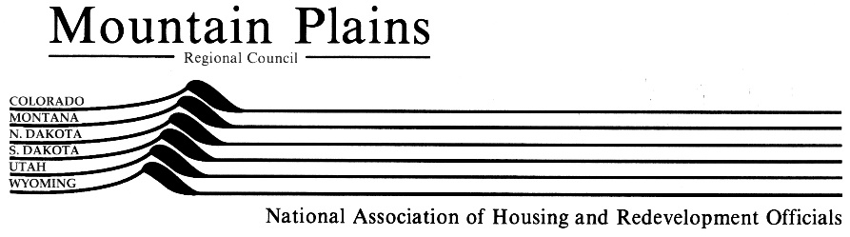

2018 SPONSOR/ VENDOR/ AD REGISTRATION FORM
Check One | Description | Price
 | Diamond Level Corporate Sponsor | $4,000
 | Emerald Level Corporate Sponsor | $3,000
Conference Sponsor (please indicate sponsorship and price from p3)
Name of Sponsorship____________________________________
Price_________________________________________________
 | Exhibit (booth) at both Maintenance and Management Conferences | $750
 | Exhibit (booth) at only the Maintenance Conference | $400
 | Exhibit (booth) at only the Management Conference | $750
Advertise only (please indicate ad size and price from p3)
Ad Size_____________________________
Ad Price_____________________________

Organization or Company:_______________________________________________________________

Contact:_______________________________________________________________________________

Address (for conference program booklet):__________________________________________________

City, State, Zip:_________________________________________________________________________

Email: Phone: ________________________________

Person(s) on Name Badge:_________________________________________________________________________________

Total Amount: _________________(Please include payment with registration or contact
Dave Martens to request credit card payment at: davem@mpnahro.org )

Pay by Credit Card  Contact Dave Martens at 303-447-0690 or davem@mpnahro.org  A Paypal Invoice will be emailed to you for payment  Email your registration form to davem@mpnahro.org or mail to:  705 Iris Ave., Boulder, CO 80304 or fax to 303-402-1959 | Pay by Check  Make check payable to: Colorado NAHRO  Mail payment & registration to:  Attention: David Martens, Colorado NAHRO  705 Iris Ave., Boulder, CO 80304

Please photocopy this form for your records.
Corporate Sponsorships are due by February 1, 2018.
Conference Sponsorships are due by April 2, 2018.
CONFERENCE DATES: MAINTENANCE, May 14-15; MANAGEMENT, May 16-18, 2018
CONFERENCE LOCATION: Vail Marriott Resort Hotel.
Questions? Contact David Martens: 303-447-0690 or davem@mpnahro.org.

PROGRAM BOOK ADVERTISING SPECS

Full Page Ad, Vertical Format @ 8" wide x 10.5" high

Half Page Ad, Horizontal Format @ 8" wide x 5.125" high

Quarter Page Ad, Vertical Format @ 3.875" wide x 5.125" high

Business Card Ad @ 3.5" wide x 2" high

- All Ads are Black & White, Laser Printer Quality or Better.
- Please submit Ads electronically, convert to .pdf and email to davem@mpnahro.org.
- Photos should be at least 300 dpi.

Please email your camera- ready ads in .pdf format (preferred) by the deadline indicated below.

A packet with complete logistical information will be emailed after receiving your registration.

General conference and lodging information is available at www.conahro.org.

Mail Registration by April 2 to:
David Martens
Colorado NAHRO
705 Iris Ave.
Boulder, CO 80304

Mail or Email Ads (pdf format) to:
David Martens
Colorado NAHRO
705 Iris Ave.
Boulder, CO 80304
davem@mpnahro.org
Ads Due Not Later Than April 16, 2018
Questions- Call Dave Martens at 303-447-0690

