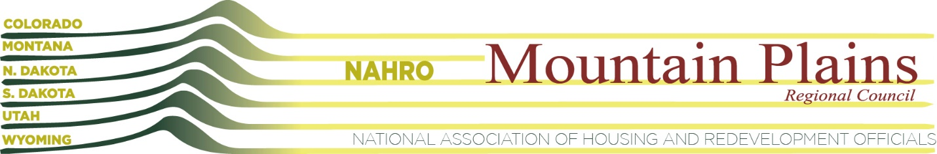
Mountain Plains NAHRO – Strategic Planning Retreat
February 5, 2019
Summary and Action Steps

Summary of Purpose: Mountain Plains NAHRO’s purpose is to provide thought leadership in the realms of advocacy and professional development for housers. Our work efforts for the next three to five years will revolve around creating an invigorated advocacy program; rethinking the annual conference; and focusing on peer to peer network connections.
ADVOCACY:
Advocacy is one of the primary reasons Board members contribute their time to Mountain Plains NAHRO. We’re stronger together.
MPNAHRO will re-invent its approach so that Advocacy is more accessible to members resulting in greater participation, and more effective in terms of outreach impacts.
Guiding Thoughts and Ideas:
- Issues are more clearly and quickly understood with direct human contact.
- We help contextualize issues by communicating the implications of a bill or leg action may have on our individual organizations.
- Peer to peer relationships can make approaching legislators easier and more productive
- Advocacy is about more than just legislators… includes cities, counties, state, Boards, HUD etc.
- Things we can do better: get clear on legislative, regulatory, and judicial contacts and priorities; increase two-way communication; and use technology better.
- Utilize current leg net and NAHRO staff as much as possible to achieve results
Action Items:
- Develop an advocacy program structure with clearly defined responsibilities
- Update email lists to be able to do current blasts
- Assign two “point people” per state
- Create a Friday night recap to all members (Tess)
- Communicate “best practices” to Advocacy group
- Have an “executive session” at regional conference that covers advocacy

RETHINKING THE ANNUAL CONFERENCE:
There is value in coming together across states. A regional conference brings people together and maximizes our human connection.
MPNAHRO wants to rethink ways to make the regional conference: more valuable to members outside of the host state; more accessible to members with travel budget issues; economically sustainable.
Guiding Thoughts and Ideas:
- The exchange of ideas across states is very helpful
- State conferences tend to be more technical with a line staff focus
- Regional conferences should include a higher-level “think summit” type component
- Regional conferences should include more peer to peer networking and exchanges
Action Items:
- Evaluate changing the conference rotation from a four-year rotation (the Dakotas, Montana, Utah, Colorado) to a two-year rotation (Utah and Colorado)
- Create a sub-committee to develop a revenue sharing proposal by June, 2019. Finalize the plan by the end of 2019
- Define dates and specific locations for the new conference rotation
- Pursue more “unconference” formats for sessions and events that allow for greater peer to peer exchanges
- Schedule a pre-conference summit for regional leadership including Executive Directors, Deputies, CFOs, Operation Directors and other thought leaders

PEER TO PEER NETWORK CONNECTIONS:
Recognizing that our peer to peer network is our most valuable asset, MPNAHRO wants to create additional opportunities through a specific “Circle of Six” initiative which brings together small groups of members who meet to share and learn from each other, and ultimately become a group of trusted advisors.
Guiding Thoughts and Ideas:
- MPNAHRO to facilitate participation and matchmaking
- MPNAHRO to develop program, set curriculum and parameters
- Update Program design with lessons learned
- Use meeting technology for video conferencing
- Rotate hosts
- Do quarterly meetings (or more?)
- After pilot study establish multiple groups of 6
- Try to include multiple states in groups when possible
- Agencies interested in participating: Adams County, Billings, Fargo, Ft. Collins, Jeffco, Sioux Falls, and Utah County
- Sample topics: property management notices and tickets; succession planning and phased retirement; Board meetings; annual reports
- Study participation fee as possible revenue source
Action Items:
- Produce initial outline of program for review by pilot circle(s)
- Pilot two groups and establish the focus
- Draft a regional survey to identify areas of interest
- Create a web site to share materials
- Establish a governance structure for long-term sustainability

OTHER ACTION ITEMS IDENTIFIED DURING RETREAT:
- New regional board meeting agenda proposed for Washington DC meeting in April. More exchange of ideas, less reporting out on things that can be read in advance.
- Support unified branding led by National NAHRO to more clearly demonstrate the link between state, regional, and national advocacy (who? Julie Brewen? When?)
- Refresh purpose and core values. Aligning mission, core values, clarity of leadership, and action tasks.
- Update website with more clear articulation of purpose and benefits
- Review National NAHRO goals and modify for regional identity – put time/resources needed here
- Committee Structure – is there any way we can reduce the committee burden at the Regional NAHRO level? (needs clarification, not sure what this means)
- Peer to peer solutions on solutions for future gov’t shut downs.
- Find a voice on big items such as climate change and deficit
- Create a media campaign that articulates goals/values.
- Be entrepreneurial, increase services to members, more Board development, performance-based contract (what’s this?)

