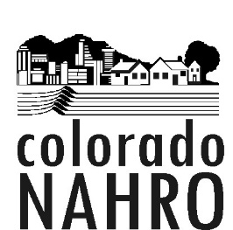

Colorado NAHRO Board of Directors
AGENDA
November 19, 2019, 9:30 am – 11:00 am
Metro West Housing Solutions
575 Union Ave., Lakewood, 80228
Call in #- 605-475-6006, Passcode 4786948#

I. Welcome and Call to Order
II. Approval of Minutes from October 15, 2019
III. President's Report-
A. Service Officer Transition
1. Conference Coordinator Chair Position
2. Executive Assistant Position
3. Brea’s Contract
B. 2020 Conference Planning Update
C. As presented
IV. Financial Report- Carol McGrath
- YTD Report
- 2020 Budget
V. Old Business/ Updates
A. Travel Scholarship Evaluation Criteria from IRGE- Julie (Do in December)
G. Document Sharing- Cory (Defer to future meeting)
VI. New Business
- CHFA Non-Profit Grant
- Other Business?
- 2020 Board Meeting Dates and Location
VII. Meeting Schedule- Next Meeting is December 17, 9:30 – 11:00 at MWHS
VIII. Adjournment

