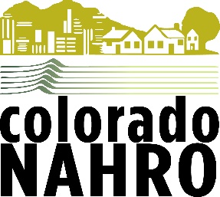
Colorado NAHRO
Travel Scholarship Program

Eligibility
Any current paid member of Colorado NAHRO that seeks assistance with travel expenses to NAHRO affiliated events excluding NAHRO state, regional or national conferences which are covered by other scholarship programs. Eligible events could include conferences or meetings being attended by a NAHRO delegation. Award recipients are expected to share their knowledge or experience with Colorado NAHRO members.
Deadline
End of first quarter in each calendar year. Additional applications after the first quarter for that calendar year will be considered depending on funding availability.
Amount of Award
CoNAHRO has budgeted a total of $2000 for travel scholarships for a two-year period beginning
January 1, 2019. Please indicate amount requested. Award reimbursements will take place after the travel or event upon receipt of an invoice from the awardee.

Name/ Title_____________________________________________________________
Organization____________________________________________________________
Address_________________________________________________________________
City/ State/Zip____________________________________________________________
Phone___________________________________________________________________
Email____________________________________________________________________
Please submit answers to the following:
Amount of award requested? What do you need the scholarship funds for? Please provide the name of the event and dates of travel.
Why do you need the travel scholarship funds and how are you funding the travel?
How will your knowledge be shared with others or how will it benefit Colorado NAHRO?

Return to: David Martens, Colorado NAHRO, 705 Iris Ave., Boulder, CO 80304- davem@mpnahro.org

