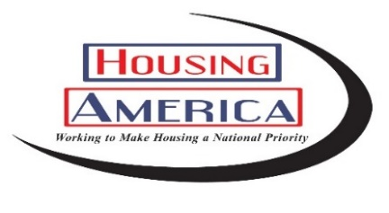

“What Home Means to Me” Poster Contest Entry Rules

Rules:
- Theme - "What Home Means to Me"
- Size – All posters must be 22” x 28” and have a LANDSCAPE/HORIZONTAL orientation to be considered for national judging and may be featured in the 2024 “What Home Means to Me” calendar.
- Media - Contestant may use any art media (marker, crayon, paint, collage, textiles, etc.), but please consider that posters will need to be packaged, mailed and reproduced.
- All entries must be mailed flat.
- All contestants must sign a release making their entry the property of NAHRO and permitting duplication/publication thereof. The release should be secured to the back of the entry.
- All regional finalists must provide their NAHRO member ID number to be considered for national judging.
- All regional finalists and national winners must sign a photo release waiver giving NAHRO permission to use their picture for online and print publication.
- All contestants are asked to provide a short narrative on the inspiration, vision, and importance of their poster design. The narrative should be secured on the back of the entry.
- Contestants name, grade level, and housing authority must be written on the back of each poster entry in addition to being listed on the release form also attached to the entry.
- NAHRO is only responsible for returning the original poster to the national grand prize winner. NAHRO is not responsible for returning posters except for the grand prize-winning poster.
- National winners will be selected based on how well the artwork uses the “What Home Means to Me” theme.
Eligibility and Selection Categories:
Contest participation is open to all children in grades K-12 residing in affordable housing assisted directly, supported under community development, or participants in affordable housing programs administered by a NAHRO member authority (i.e., public or Section 8-assisted housing CDBG, HOME, LIHTC). Entries must be created by only one person. Entries created by two or more people will not be accepted.

Age Categories:
Elementary: K to 5th grade;
Middle: 6th to 8th grade;
High: 9th to 12th grade

Contest Overview:
1) NAHRO member housing authorities submit their entries to their local/state NAHRO chapter. If your local/state NAHRO chapter does not hold a poster contest, contact your NAHRO regional council for more information regarding their poster competition.
2) Local/state NAHRO chapters may submit entries to their regional council.
3) The regional councils hold separate contests and send their top three winners (one from each age category) to NAHRO.
4) NAHRO holds a national contest to pick the 13 national winners.

IMPORTANT: All regional finalists must provide their NAHRO member ID number to be considered for national judging.
*If you don’t know your member ID, please contact Libby Miller at lmiller@nahro.org.

Local Chapter/State Competitions:
Housing authorities must be active NAHRO members to participate in the “What Home Means to Me” poster contest.

Housing authorities submitting entries to the national poster contest must first send entries to their local/state NAHRO chapter or NAHRO regional council.

While local state/chapter contests are optional, NAHRO encourages local/state NAHRO chapters to host their own poster contests and submit the winning posters to their regional council. If your local/state NAHRO chapter does not hold a poster contest, contact your NAHRO regional council for more information regarding their poster competition.

NAHRO will not accept submissions from individual housing authorities or state associations. Any submissions sent directly to NAHRO will be disqualified.

Regional Council Competitions:
Each regional council will determine a deadline for their poster contest entries and a date for regional judging. NAHRO is not involved in the scheduling or management of regional council contests. The eight regional councils will select three winners –one from each age category – and forward those winners to the national competition in Washington, D.C.
National Competition:
National honorees will be selected by a panel of judges assembled by NAHRO staff. National honorees will be announced during Housing America Month in October. All eight NAHRO regions will be represented in the calendar.

For NAHRO Regions:
Deadline for submission of regional honorees to NAHRO is July 7, 2023.
To submit: please email a photo of the regional winners to Libby Miller at lmiller@nahro.org in addition to mailing the physical poster to the NAHRO office.

Only regional honorees should be mailed to:
NAHRO-2023 Poster Contest
Attn: Libby Miller
630 Eye Street NW
Washington, DC 20001

Additionally, please send a photo of each poster being mailed to Libby Miller at lmiller@nahro.org.
National Prizes
The grand prize cover winner will also receive an iPad and a framed copy of their original artwork. The cover winner and one legal guardian will also receive a tour of Capitol Hill and attend NAHRO’s Washington Conference in Washington, D.C. where he or she will be honored. The 12 national winners will each receive a $100 Visa gift card.
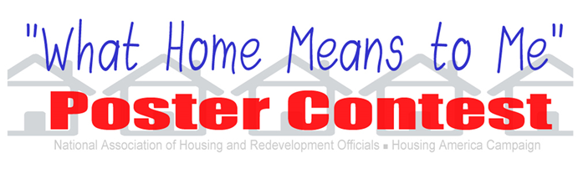
Application

Name of Applicant-artist: _______________________________________

Address: _____________________________________________________

City ______________________ State ________ Zip code __________

Housing Agency: _______________________________________________

Age category: Elementary: K-5th (___) Middle: 6th-8th (___) High: 9th -12th (___)

Applicant’s Age: ______

Name of Parent or Guardian: _____________________________________
(Required if applicant is under 18 years of age)

Conditions of submission:
Applicant and parent or guardian understand and agree that upon submission of the applicant’s poster, the poster will become the sole property of the National Association of Housing and Redevelopment Officials (NAHRO). NAHRO shall have exclusive and full rights to copy, reproduce and distribute the poster in connection with its poster calendar and may retain the original of any poster. Applicant, and parent or guardian for and on behalf of applicant, hereby release and discharge NAHRO and any and all Regional Councils, State Chapters or other affiliates of NAHRO from any and all liabilities, claims, suits, or actions, including without limitation any claim to payment of compensation, in connection with NAHRO’s possession, use, copying, reproduction, and/or distribution of the applicant’s poster.

By signing this application below, applicant, and any parent or legal guardian signing on applicant’s behalf, hereby indicate agreement to the conditions stated above. Any person signing as guardian further represents that he or she is fully and lawfully empowered to act as guardian for the applicant.

Signature of Applicant: _____________________________________________

Signature of Parent Guardian: _______________________________________

Local Housing Agency Contest Representative Contact Information
(Local Housing Agency Office Only)

Name: ________________________________________________________

Email: ________________________________________________________

Phone: ________________________________________________________
"What Home Means to Me"
Please write a short paragraph (100 words or less) explaining your poster.

NAHRO PHOTO RELEASE FORM

I hereby grant NAHRO permission to use my likeness in a photograph, video, or other digital media (“photo”) in any and all its publications, including web-based publications, without payment or other consideration.

I understand and agree that all photos will become the property of NAHRO and will not be returned.

I hereby irrevocably authorize NAHRO to edit, alter, copy, exhibit, publish, or distribute these photos for any lawful purpose. In addition, I waive any right to inspect or approve the finished product wherein my likeness appears. Additionally, I waive any right to royalties or other compensation arising or related to the use of the photo.

I hereby hold harmless, release, and forever discharge NAHRO from all claims, demands, and causes of action which I, my heirs, representatives, executors, administrators, or any other persons acting on my behalf or on behalf of my estate have or may have by reason of this authorization.

I HAVE READ AND UNDERSTAND THE ABOVE PHOTO RELEASE. I AFFIRM THAT I AM AT LEAST 18 YEARS OF AGE, OR IF I AM UNDER 18 YEARS OF AGE, I HAVE OBTAINED THE REQUIRED CONSENT OF MY PARENT/GUARDIAN AS EVIDENCED BY THEIR SIGNATURES BELOW. I ACCEPT:

____________________________
Print Name

Signature Date

If under 18, PARENT/GUARDIAN MUST SIGN

__________________
Parent/Legal Guardian Date

